Public Health

Henry County Health Center
Annual Report 2022
TABLE OF CONTENTS

- PUBLIC HEALTH OVERVIEW
- HCHC PROGRAMS
- 2022 EVENT SPOTLIGHTS
- NEW FACES
- MILESTONE MET
- NUMBERS SERVED
- NEW INITIATIVES
- FINANCIAL SNAPSHOT
- SEE YOU IN 2023

PUBLIC HEALTH OVERVIEW:

Public Health focuses on the overall improvement of life:
Henry County Health Center (HCHC) employees’ work ranges from analyzing health trends in the community, to preventing the spread of communicable diseases. HCHC believes that everyone deserves a chance to lead a healthy and happy life, therefore, we are focused on attaining the highest level of health for all Henry County (HC) residents.

The HCHC Strategic Plan is focused on developing and sustaining programs that align with our mission and with the needs that are identified in our Community Needs Assessment. HCHC is also focused on developing good working relationships with partners in the community that will increase the odds of long-term change.

HCHC Mission:
“To create a stronger community by promoting health, providing quality resources and protecting the overall wellness of Henry County residents.”

Program Operations:
The community and site-based programs provided by HCHC are listed on the next page

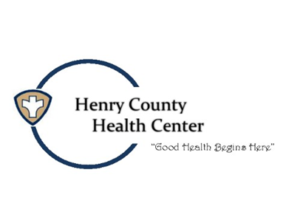
HCHC PROGRAMS:

The Community Needs Assessment drives the
Henry County Health Center Strategic Plan.

2022 YEAR IN REVIEW:

AED REPLACEMENT PADS FOR HC SCHOOLS
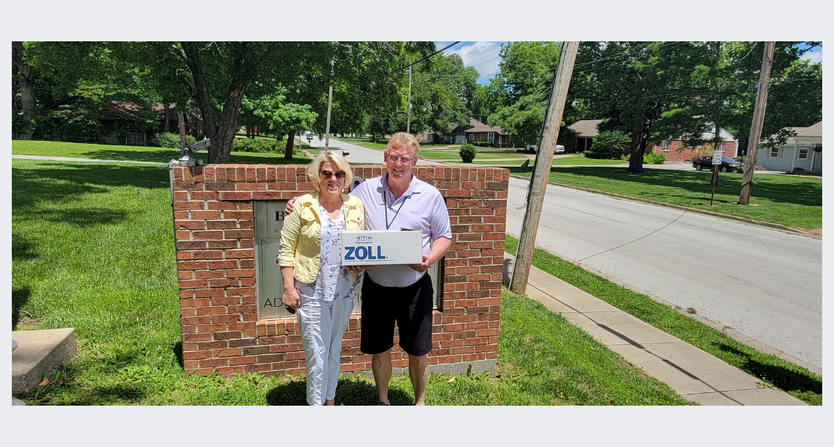
RABIES CLINIC
200 HC RESIDENTS SERVED

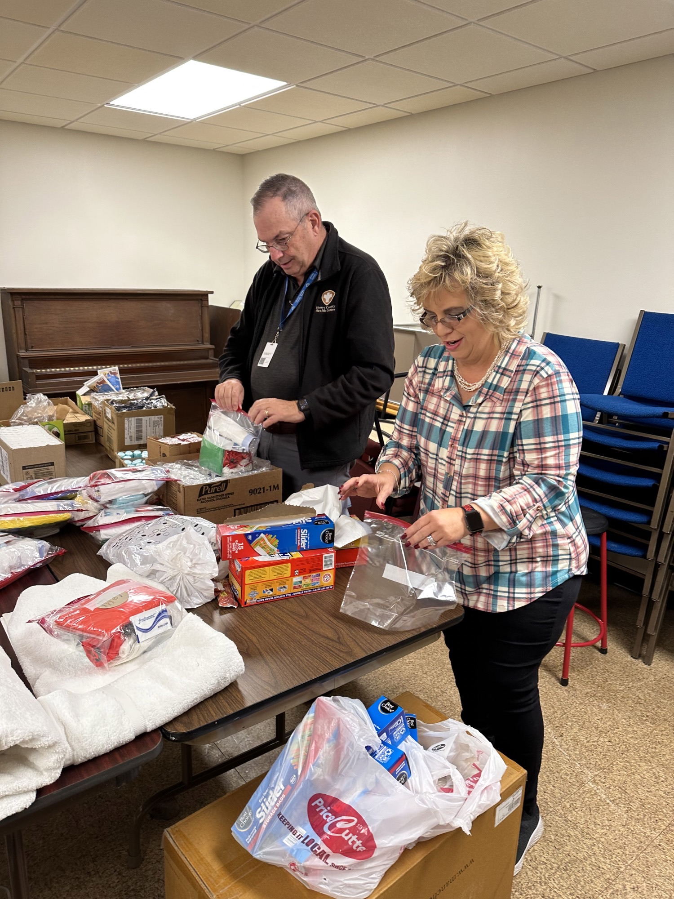
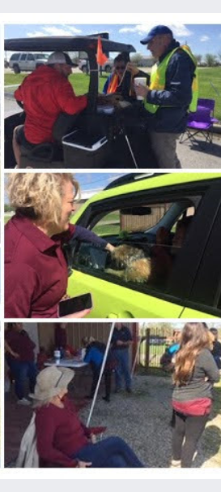
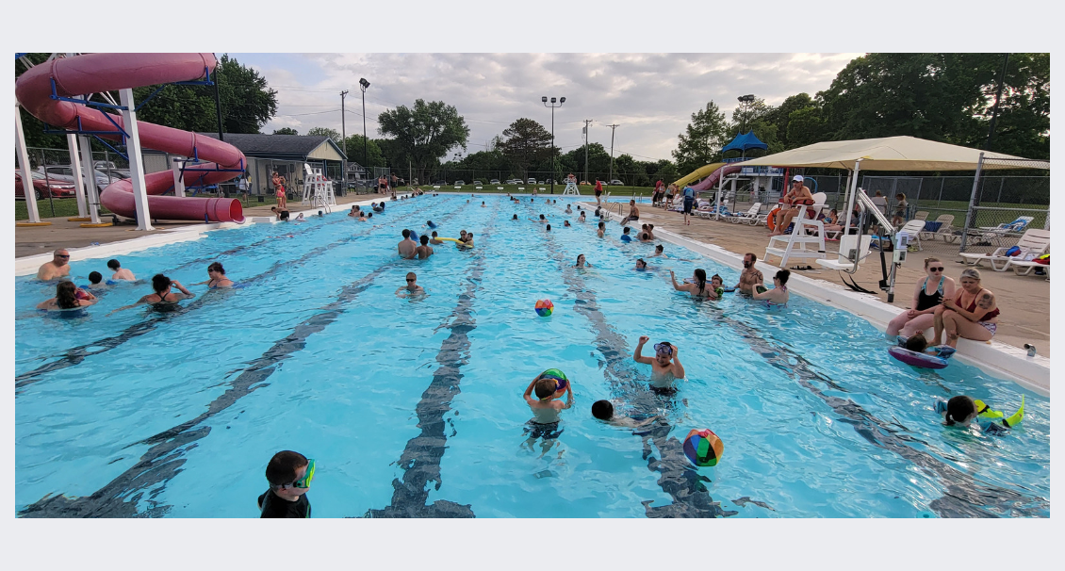
H.C. HOMELESS KITS
RECOGNIZING CLINTON SCHOOLS STUDENTS
OF THE MONTH
VEST FOR NEW POLICE OFFICER
FREE SWIM FOR FAMILES

HCHC WELCOMES NEW FACES:

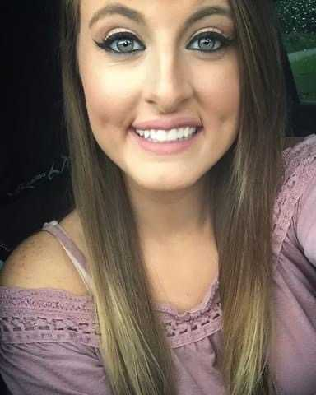
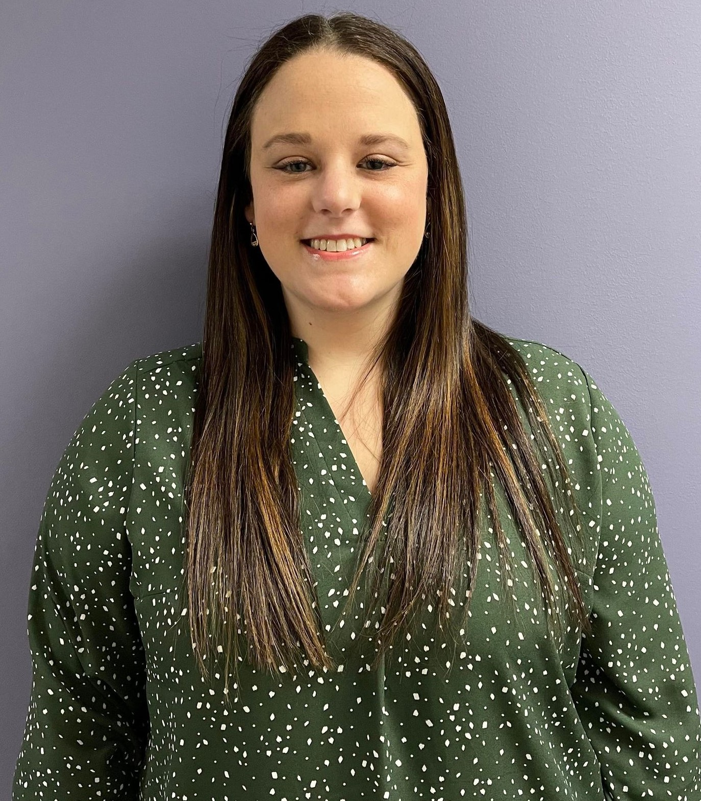
Allison Dickey
Contract Nurse
Debra Rosebrough
Contract Nurse
Tyler Pulcini
Contract Nurse
Presley Schneck, WIC
Contract Nurse
Lauren Bauer
Contract Nurse
Carla Wade, RN
Contract Nurse
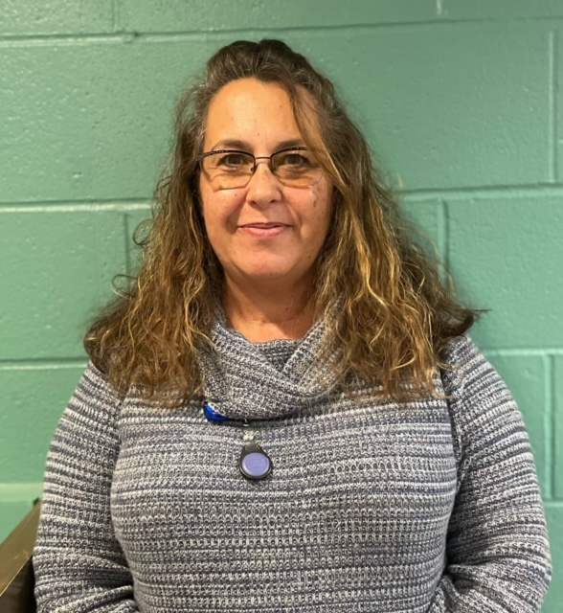
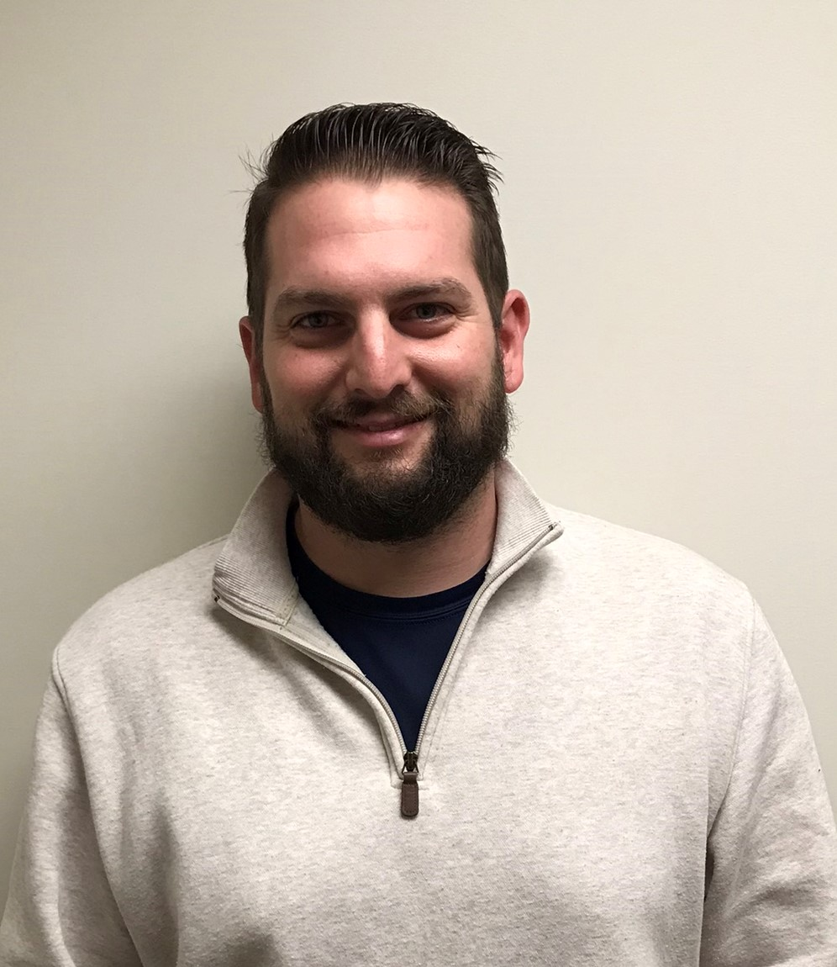

MILESTONE MET:

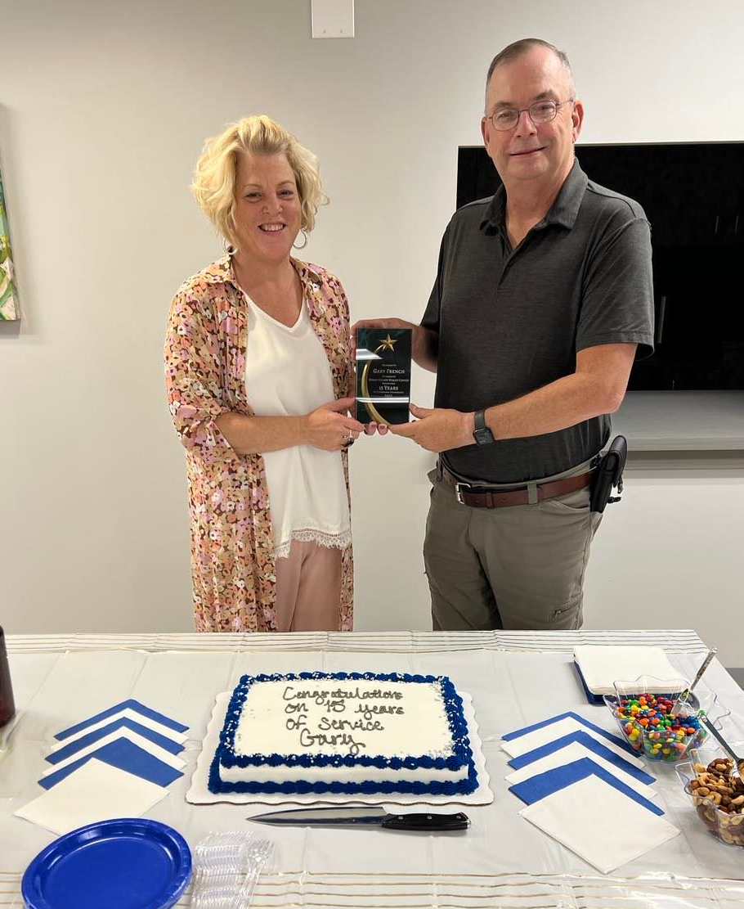
GARY FRENCH
Celebrated
Fifteen Years of Service

HC NUMBERS SERVED BY PERCENTAGE:

TWO NEW INITIATIVES TAKE HOLD:

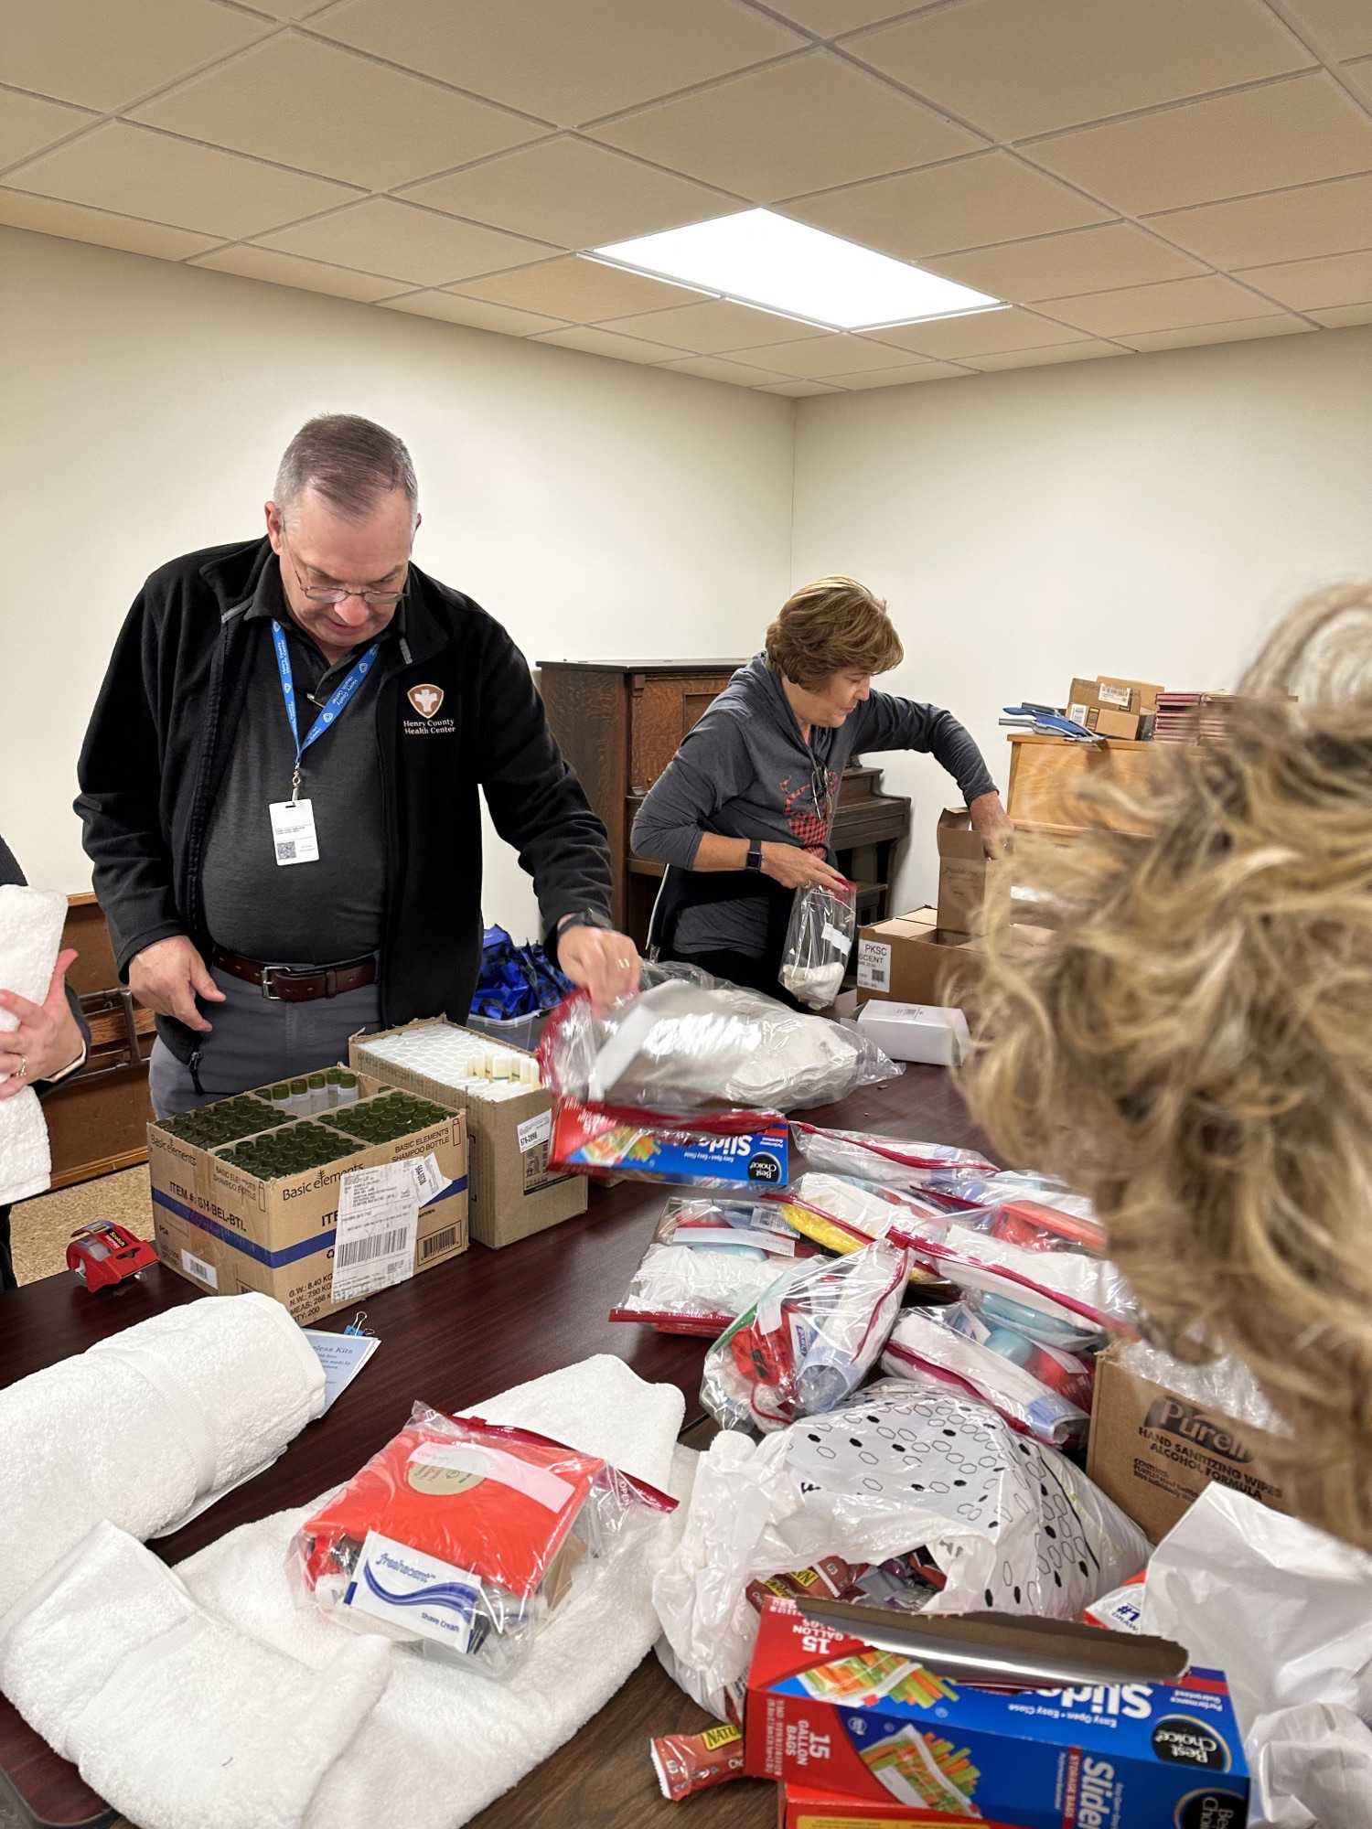
Homeless Kits for Henry County Homeless
- 25 Adult Kits (Pictured)
- 40 Teen Kits

Battery Recycling:
80 lbs. recycled

FINANCIAL SNAPSHOT - REVENUE:

SEE YOU IN 2023!!!

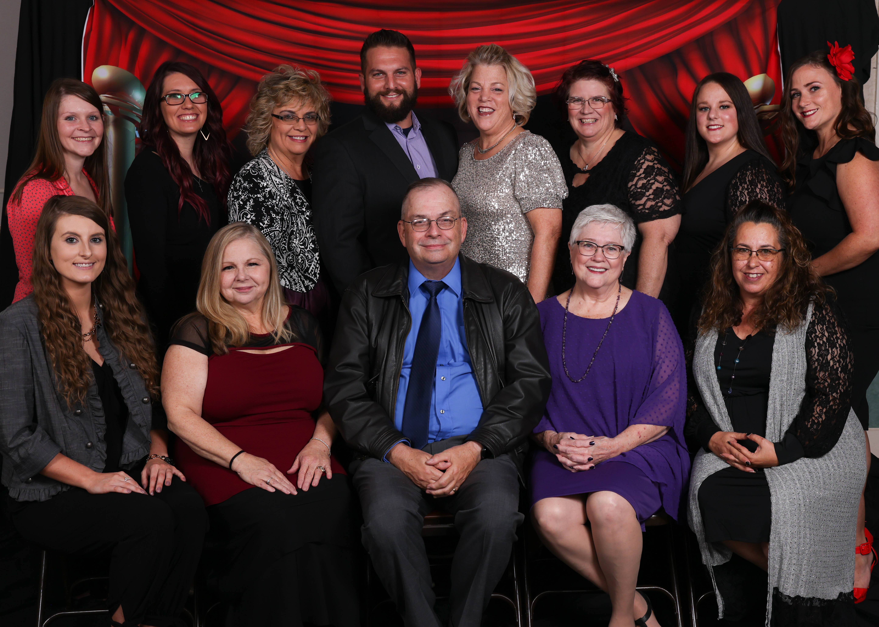
S
PICTURED LEFT TO RIGHT BACK ROWN: Allison Dickey, Katrina Keithley, Dana Hall, Tyler Pulcini, Peggy Bowles, Tonya Chandler, Lauren Bauer, Tanya Hamilton. FRONT ROW: Presley Schneck, Helen Ritter, Gary French, Marie Courtney, and Debra Rosebrough.

